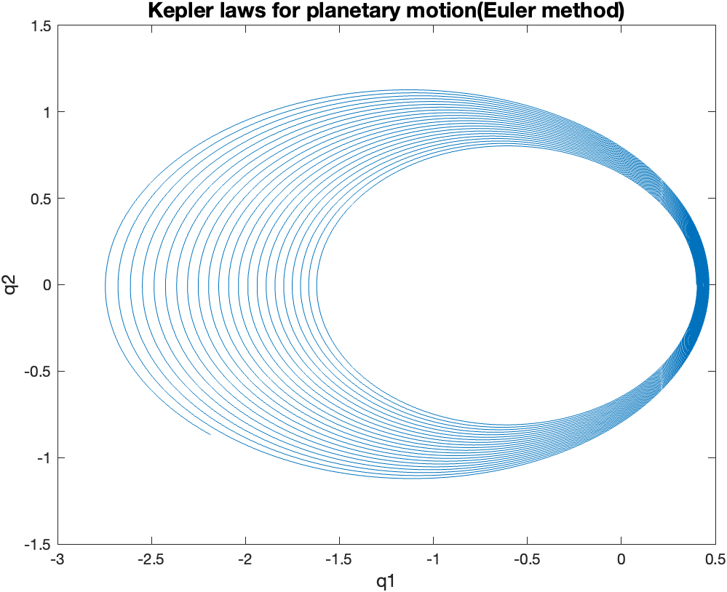Computing Assignment 8

We were tasked with modeling the elliptical orbit of a planet revolving around another planet.

It can be observed that by using the Euler’s method the orbit of the planet is incorrect since it shows a series of ellipses going further away from the initial approximation implying that the planet spirals away instead of having one fixed orbit as the time increases. This happens because the error increases with time.

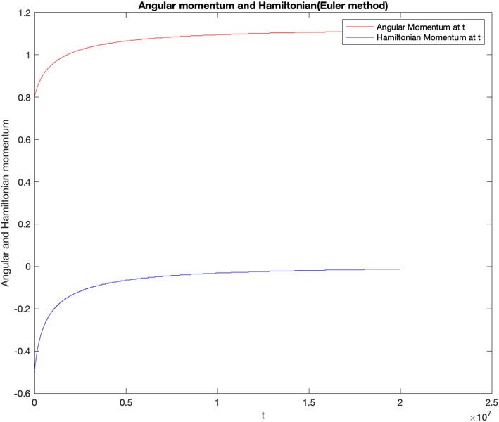The figure shows that the standard Euler’s method doesn’t conserve Angular and Hamiltonian Momentum.

In reality they are constants whereas in our method they follow a step-like patterns.

When we increase ‘time’ to 10,000 we can observe that angular momentum approaches 1.1 and Hamiltonian momentum approaches 0. Therefore, it is better conserved for larger values of time.

The Symplectic Euler’s method is accurate as it depicts a closed elliptical orbit for each iteration which aligns with reality. It no longer diverges. It also conserves the Angular and Hamiltonian momentum as the change is almost negligible as was shown experimentally by plotting them from time [0,10000]

